**ELEVATE LAB “SQL DEVELOPER TASK – 5”**

**EMPLOYEE MANAGEMENT SYSTEM DATABASE**

_____________________________________________________________________________________

**CREATING EMPLOYEES TABLE:**

**CODE:**

-- Create Customers table

CREATE TABLE Customers (

customer_id INTEGER PRIMARY KEY,

name VARCHAR(100),

city VARCHAR(100)

);

-- Create Orders table

CREATE TABLE Orders (

order_id INTEGER PRIMARY KEY,

customer_id INTEGER,

amount DECIMAL(10, 2),

order_date DATE,

FOREIGN KEY (customer_id) REFERENCES Customers(customer_id)

);

INSERTING VALUES:

**-- Insert into Customers**

INSERT INTO Customers (customer_id, name, city) VALUES

(1, 'Shamish', 'Hyderabad'),

(2, 'Surya', 'Chennai'),

(3, 'Charan', 'Mumbai'),

(4, 'Om Naidu', 'Bangalore');

**-- Insert into Orders**

INSERT INTO Orders (order_id, customer_id, amount, order_date) VALUES

(101, 1, 5000.00, '2025-06-01'),

(102, 2, 3000.00, '2025-06-02'),

(103, 1, 2500.00, '2025-06-03'),

(104, 3, 4000.00, '2025-06-04');

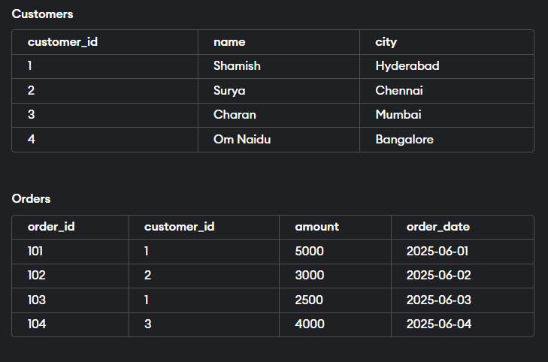

**INNER JOIN:**

SELECT c.customer_id, c.name, o.order_id, o.amount

FROM Customers c

INNER JOIN Orders o ON c.customer_id = o.customer_id;

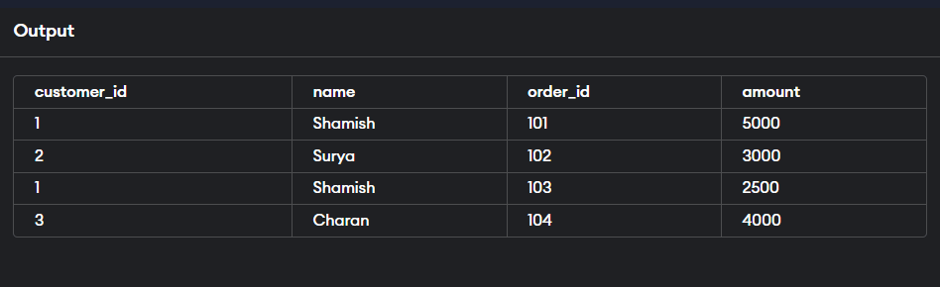

**LEFT JOIN**

SELECT c.customer_id, c.name, o.order_id, o.amount

FROM Customers c

LEFT JOIN Orders o ON c.customer_id = o.customer_id;

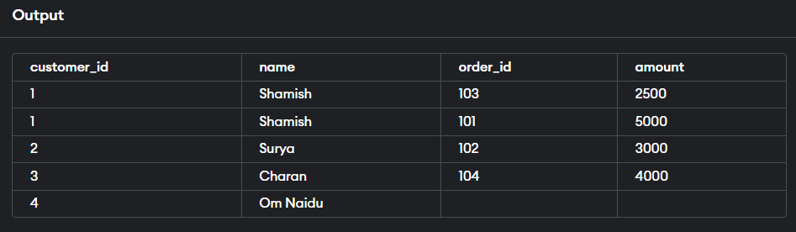

**RIGHT JOIN:**

SELECT c.customer_id, c.name, o.order_id, o.amount

FROM Customers c

RIGHT JOIN Orders o ON c.customer_id = o.customer_id;

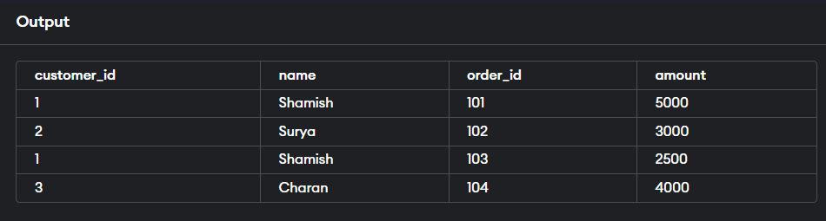

**FULL JOIN:**

SELECT c.customer_id, c.name, o.order_id, o.amount

FROM Customers c

FULL OUTER JOIN Orders o ON c.customer_id = o.customer_id;

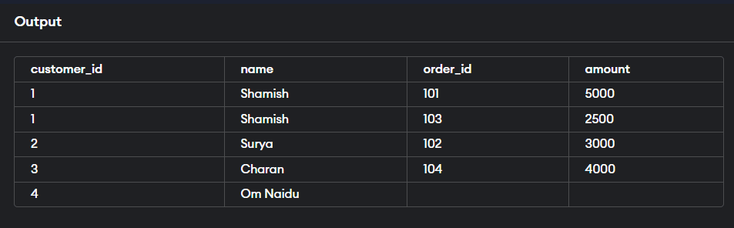

______________________________________________________________________________

NAME : Bodavula. Saivenkat

Email: [saivenkat.bodavula@gmail.com](mailto:saivenkat.bodavula@gmail.com)

Github: <https://github.com/saivenkat182004/ELEVATE-LABS-TASK-5>